6.84: The arrow will acquire the energy that was used in drawing the bow (i.e., the work done by the archer), which will be the area under the curve that represents the force as a function of distance. One possible way of estimating this work is to approximate the F vs. x curve as a parabola which goes to zero at 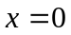 and 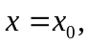 and has a maximum of 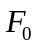 at 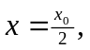 so that 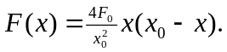 This may seem like a crude approximation to the figure, but it has the ultimate advantage of being easy to integrate;
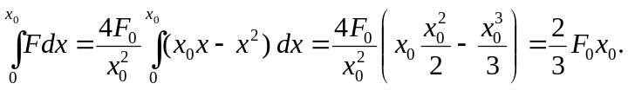
With 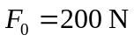 and 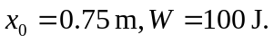 The speed of the arrow is then 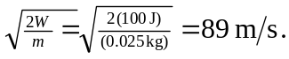 Other ways of finding the area under the curve in Fig. (6.28) should give similar results.

